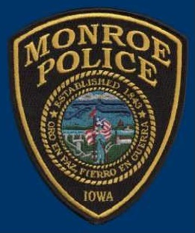 | Monroe Police Department  Business Security Check Program  “Creating Partnerships to build a Stronger and  Safer Community”

Name of Business: | Date of request:
Address of Business: | Business Phone #:
Business Email Address:
Owner/Manager: | Contact Phone #:
Secondary Contact Person: | Contact Phone #:
Key Holder:  (after hours contact) | Contact Phone #:

The Monroe Police Department is pleased to offer the Business Security Check Program to local businesses.

This program involves an officer coming to your place of business and completing a security checklist with you to determine strengths and weaknesses of your security.

Upon completion of a security check, a completed checklist is given to you. The checklist reflects any security deficiencies found, and the officer will offer tips to make your business more secure.
Additional Information you want to make officers aware of:

Signature: | Date:

